Local Media and Social Media Toolkit
2026 OSUM Conference

The 2026 Ontario Small Urban Municipalities (OSUM) Conference runs from Wednesday, April 29 to Friday, May 1 in the Town of Parry Sound. The conference serves as a key moment for municipal and provincial officials to connect on the unique challenges faced by small urban municipalities.

You can help OSUM maximize media and social media coverage of municipal priorities and amplify the value of conference participation by municipal councils and staff by using the local media and social media toolkit provided.

Social Media and News Release Templates

We have attached templates that will make it easy to share content on Facebook, LinkedIn, X or Instagram. We encourage you to create your own content using the conference hashtag, #OSUM2026, and to follow OSUM on LinkedIn.

We are also attaching a template Media Advisory that will help you prepare notices for local media. Media is invited to attend the conference and must register upon arrival. For the first time, accredited media from across Ontario will also be able to tune in remotely to conference content. The template advisory provides the details.

Reporters are always looking for the local angle for a broader story. Making yourself or local municipal officials available for interviews provides an opportunity to highlight how you are working collaboratively through OSUM to address local community priorities.

Lastly, you may be wondering if you are an OSUM member. The answer is most likely, “Yes”. OSUM does not have membership fees, or a formal registration process. Rather, it serves as the voice for small cities, towns and counties under the umbrella of the Association of Municipalities of Ontario (AMO). OSUM’s goal is to help these communities navigate the unique challenges they face. If you are a member of AMO and come from a small city, town or county government, then you are part of OSUM.

Conference Highlights and Details

The OSUM conference will feature presentations on Strong Mayor Powers, the changing landscape of municipal communications and local media, and fostering respectful leadership in local government. Other sessions will focus on AMO’s groundbreaking homelessness study, public libraries, local infrastructure and Indigenous relations.
Participants will hear from keynote speaker and award-winning journalist Althia Raj. Associate Minister of Municipal Affairs Graydon Smith will also speak.
Please take a moment to review the program and identify the sessions that may be of interest to your municipality and local media. Familiarizing yourself with the content will make it easy for you to explain how your attendance at the conference will benefit your community. Full program details are available on the OSUM website.

If you have any questions regarding conference communications, please contact Farah Tayabali, OSUM Media Relations, tayabali@redbrick.ca, 416-570-8413.

Social Media Templates

The following templates are designed to help you communicate your participation in the 2026 OSUM Conference. The OSUM Conference hashtag is #OSUM2026.

NOTE: Please use the higher quality ‘OSUM Social Post’ graphics available for download separately. Saving images from this Word document will result in a much lower-quality image. The toolkit includes posts sized for Facebook/LinkedIn/X and Instagram.

POST 1 – Conference Preview

[Name of Reeve / Mayor / Chair] of [Name of Community / Social Handle] will be taking part in the OSUM Conference from April 29 to May 1, as OSUM celebrates 70 years of municipal support and leadership for Ontario’s small urban communities. #OSUM2026 https://www.osum.ca

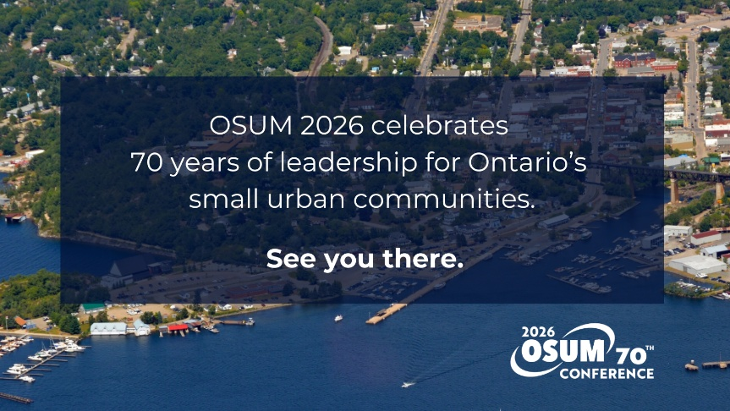

OR

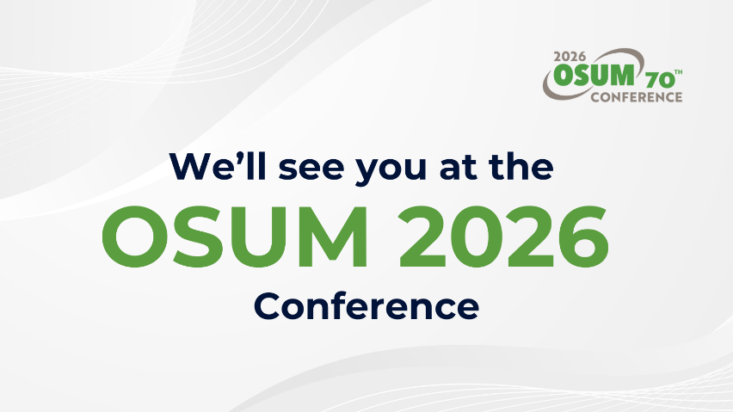

POST 2

[Municipality name / account name] is attending #OSUM2026. Connecting with other municipal leaders is an opportunity to learn and explore solutions together during a time of growing uncertainty in our communities.

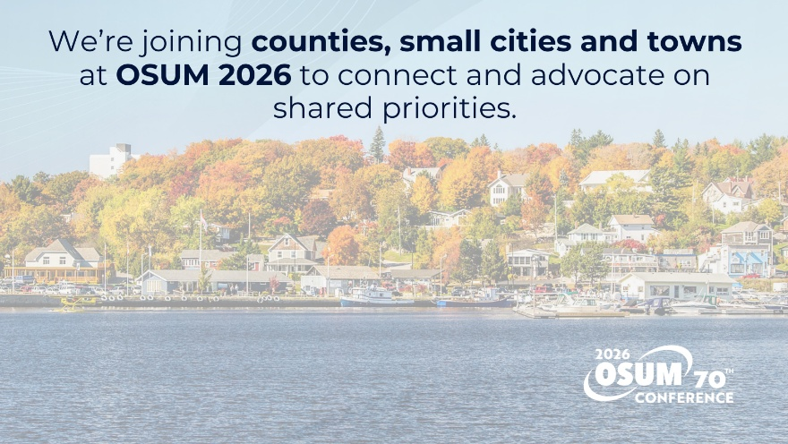

POST 3

The #OSUM2026 Conference is a place for municipal colleagues to come together and act as a united voice on the things that matter to Ontario’s small urban communities.

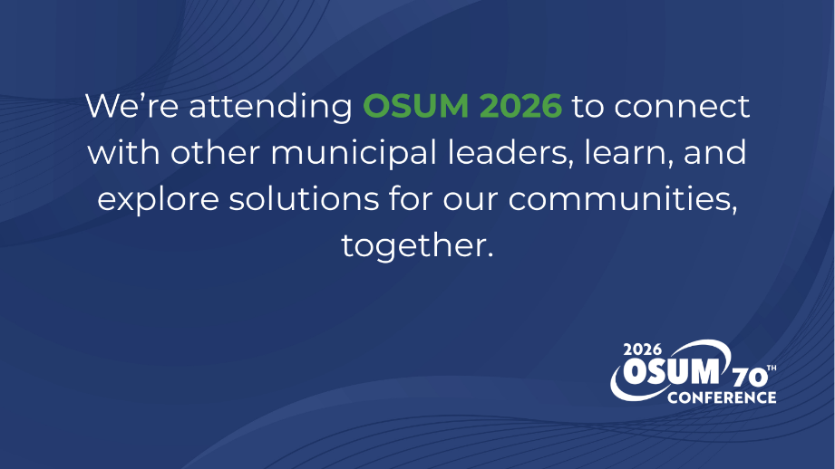

Media Advisory
[DATE]

[NAME OF MAYOR / REEVE / CHAIR] Available for Interviews
During 2026 Ontario Small Urban Municipalities Conference

[NAME OF COMMUNITY] – [NAME OF MAYOR / REEVE / CHAIR] will join participants from across the province at the 2026 Ontario Small Urban Municipalities (OSUM) Conference. The conference is hosted by the Town of Parry Sound from April 29 to May 1, 2026.

Municipal leaders from small cities, towns and counties are gathering to explore solutions to shared challenges amid a time of economic and political uncertainty.

Key presenters for the 2026 conference include award-winning journalist Althia Raj, and John Mascarin, Partner, Aird & Berlis LLP, who will speak to strong mayor powers, and whether they’re being used effectively by local governments.

Sessions will focus on priority topics for Ontario’s small urban communities, including homelessness, infrastructure, the changing landscape of municipal communications, Indigenous relations, and insights from AMO’s latest Healthy Democracy work, the Leading with Respect Strategy.

[NAME OF MAYOR / REEVE / CHAIR] is particularly interested in sessions related to…

During the conference, interviews with [NAME OF MAYOR / REEVE / CHAIR] can be accommodated by calling [NAME, POSITION, TELEPHONE NUMBER].

This year, some conference content will be available for media to view remotely via video conference. Media are asked to register in advance for in person or online access by emailing tayabali@redbrick.ca. Media may also visit the main registration desk onsite during the conference. Attending media are encouraged to book accommodation as soon as possible.

About OSUM: Ontario Small Urban Municipalities (OSUM) supports vibrant counties, small cities and towns that connect urban and rural Ontario. While no two communities are alike, small urban municipalities face shared challenges and opportunities that can be both urban and rural in nature. OSUM’s work is driven by an Executive Committee with members hailing from small single-tier cities, suburban towns, rural municipalities and counties. The Executive Committee all sit on the Association of Municipalities of Ontario (AMO) Board’s small urban caucus. OSUM’s advocacy work is supported by staff at AMO.
-30-

For more information about OSUM or the 2026 Conference, contact:
Farah Tayabali, OSUM Media Relations, 416-570-8413, tayabali@redbrick.ca

